Instructions for Payment through SBI Collect

- Open the link
https://onlinesbi.sbi.bank.in/sbicollect/icollecthome.htm

- Click on Educational Institutes
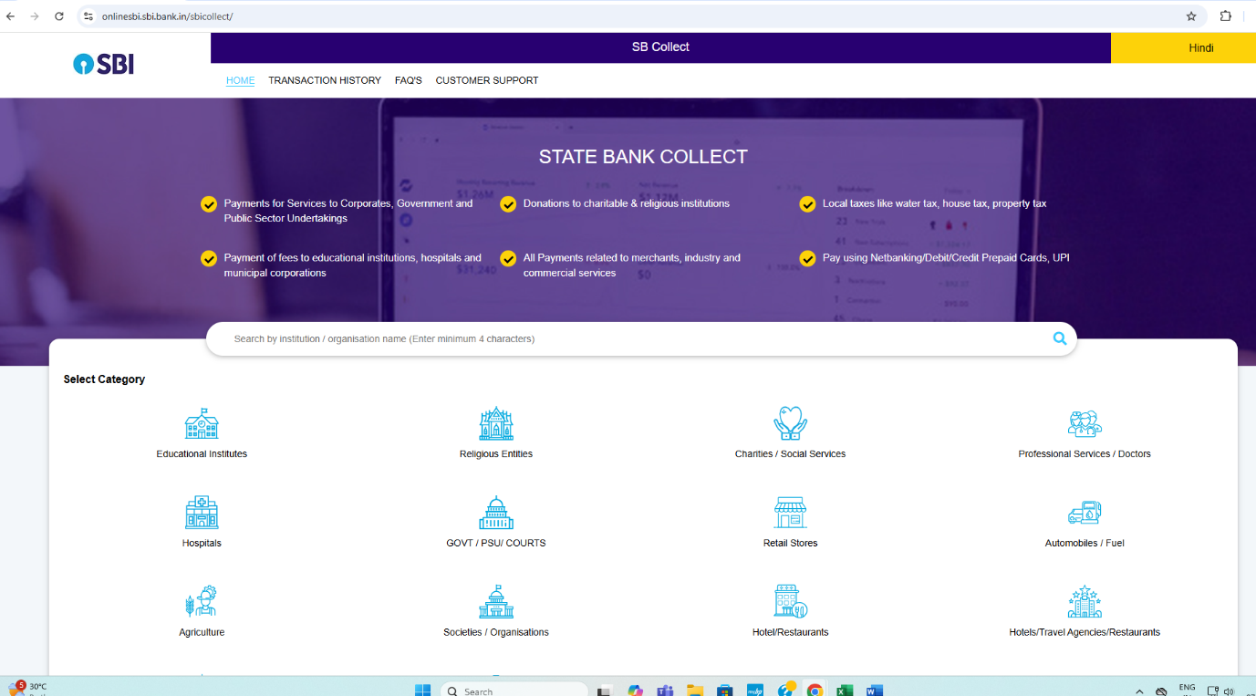

- Choose Madhya Pradesh in Filter by State
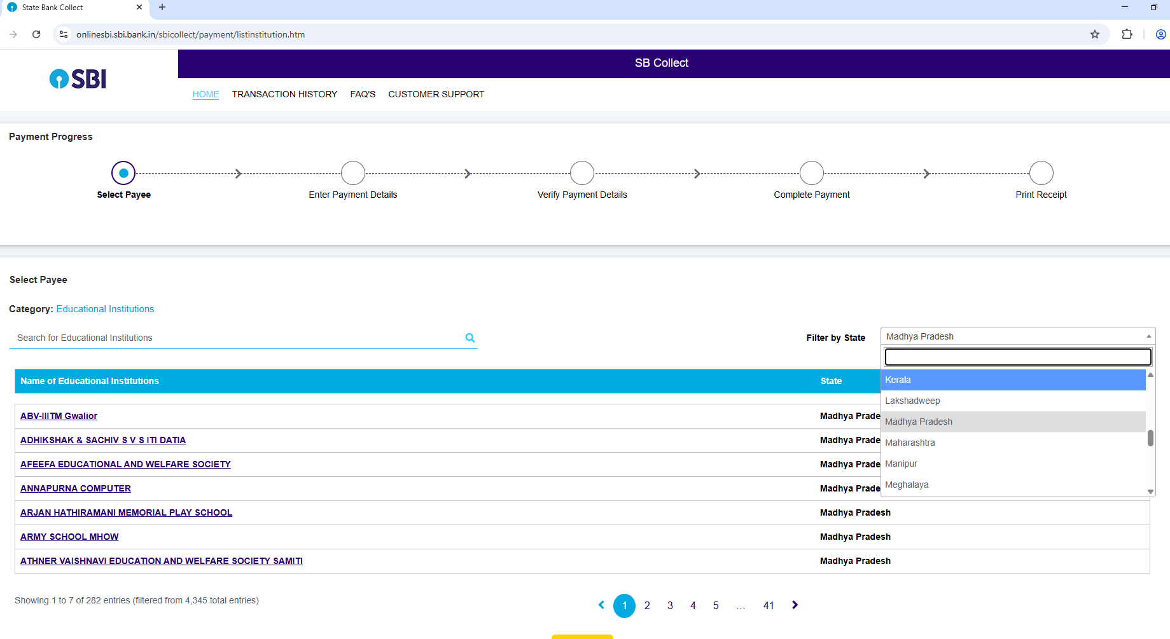

- Choose ABV-IIITM Gwalior in Educational Institutions
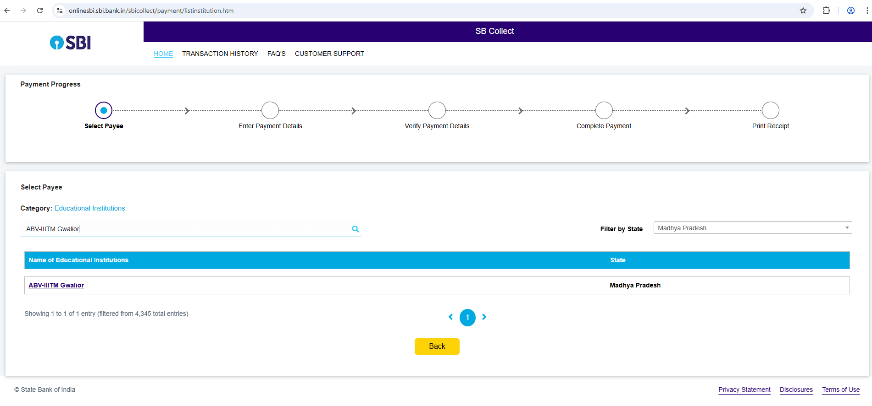

- Choose INSPECT 2025
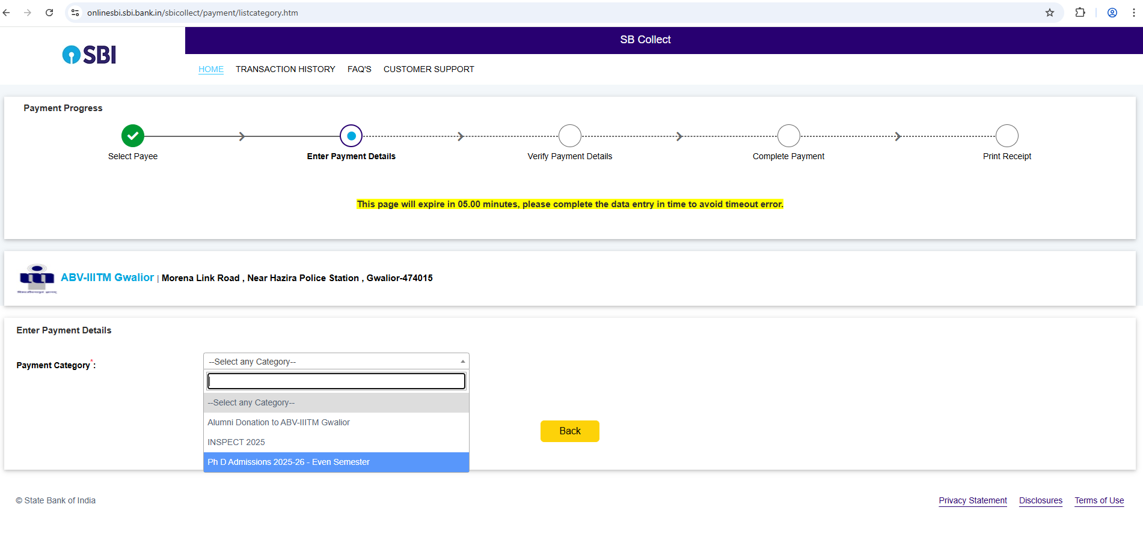

- Make a payment.

